EX. NO: | INTERACTIVE AWT-BASED GUI APPLICATION USING EVENT HANDLING
DATE: | INTERACTIVE AWT-BASED GUI APPLICATION USING EVENT HANDLING

AIM:
To create and implement an application using Java AWT controls and event handling to build an interactive graphical user interface.

ALGORITHM:
STEP 1: Create a Frame window.
STEP 2: Initialize a 3×3 grid with numbers.
STEP 3: Display grid using paint().
STEP 4: Add Button and Label.
STEP 5: Capture mouse click position.
STEP 6: Convert click into row & column.
STEP 7: Check if tile is adjacent to empty space.
STEP 8: Swap tile with empty position.
STEP 9: Repaint the screen.
STEP 10: Shuffle grid on button click.

PROGRAM CODE:

package puzzle;
import java.util.*;
import java.awt.*;
import java.awt.event.*;
import java.util.Random;

public class PuzzleGame extends Frame implements MouseListener, ActionListener {

int[][] grid = new int[3][3];
int emptyRow = 2, emptyCol = 2;
int size = 100;

Button shuffleBtn = new Button("Shuffle");

public PuzzleGame() {
setTitle("8 Puzzle Game");
setSize(320, 380);
setLayout(null);

shuffleBtn.setBounds(110, 310, 100, 30);
shuffleBtn.addActionListener(this);
add(shuffleBtn);

addMouseListener(this);

addWindowListener(new WindowAdapter() {
public void windowClosing(WindowEvent e) {
dispose();
System.exit(0);
}
});

initGrid();
setVisible(true);
}

void initGrid() {
int num = 1;
for(int i = 0; i < 3; i++) {
for(int j = 0; j < 3; j++) {
grid[i][j] = num;
num++;
}
}
grid[2][2] = 0;
emptyRow = 2;
emptyCol = 2;
}

void shuffle() {
Random rand = new Random();

for(int k = 0; k < 100; k++) {
int r = rand.nextInt(3);
int c = rand.nextInt(3);

if ((Math.abs(r - emptyRow) == 1 && c == emptyCol) ||
(Math.abs(c - emptyCol) == 1 && r == emptyRow)) {

grid[emptyRow][emptyCol] = grid[r][c];
grid[r][c] = 0;

emptyRow = r;
emptyCol = c;
}
}
repaint();
}

public void paint(Graphics g) {

// Double buffering to avoid flicker
Image img = createImage(getWidth(), getHeight());
Graphics bg = img.getGraphics();

bg.setColor(Color.WHITE);
bg.fillRect(0, 0, getWidth(), getHeight());

for(int i = 0; i < 3; i++) {
for(int j = 0; j < 3; j++) {

int x = j * size;
int y = i * size;

bg.setColor(Color.BLACK);
bg.drawRect(x, y, size, size);

if(grid[i][j] != 0) {
bg.setFont(new Font("Arial", Font.BOLD, 28));

String num = String.valueOf(grid[i][j]);
FontMetrics fm = bg.getFontMetrics();

int tx = x + (size - fm.stringWidth(num)) / 2;
int ty = y + (size + fm.getAscent()) / 2;

bg.drawString(num, tx, ty);
}
}
}

g.drawImage(img, 0, 0, this);
}

public void mouseClicked(MouseEvent e) {

int row = e.getY() / size;
int col = e.getX() / size;

if(row > 2 || col > 2) return;

if ((Math.abs(row - emptyRow) == 1 && col == emptyCol) ||
(Math.abs(col - emptyCol) == 1 && row == emptyRow)) {

grid[emptyRow][emptyCol] = grid[row][col];
grid[row][col] = 0;

emptyRow = row;
emptyCol = col;

repaint();

if (isWin()) {
showWinMessage();
}
}
}

// Check win condition
boolean isWin() {
int num = 1;
for(int i = 0; i < 3; i++) {
for(int j = 0; j < 3; j++) {
if(i == 2 && j == 2) return true;
if(grid[i][j] != num++) return false;
}
}
return true;
}

void showWinMessage() {
Dialog d = new Dialog(this, "Congrats!", true);
d.setLayout(new FlowLayout());
d.add(new Label("You solved the puzzle! 🎉"));

Button ok = new Button("OK");
ok.addActionListener(e -> d.dispose());

d.add(ok);
d.setSize(200, 100);
d.setLocation(150, 150);
d.setVisible(true);
}

public void actionPerformed(ActionEvent e) {
shuffle();
}

public void mousePressed(MouseEvent e){}
public void mouseReleased(MouseEvent e){}
public void mouseEntered(MouseEvent e){}
public void mouseExited(MouseEvent e){}

public static void main(String[] args) {
new PuzzleGame();
}
}

OUTPUT:

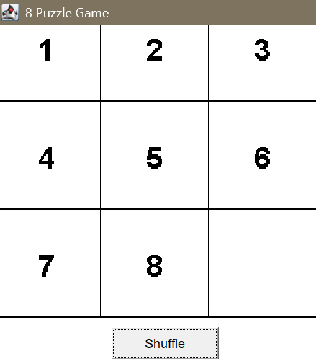

RESULT:
The program has been executed successfully.

